# **Connected Operations (COps) Platform**

# User’s Guide

# 

# 

# **Skyward Federal**

# **CSC 492: Team 32**

# Jonathan Balliet

# Caleb Boswell

# Daniel Mills

# Jeen Shaji

# Spencer Yoder

## 

|  |  |
| --- | --- |
| Primary Author | Daniel Mills |
| Editor | Jeen Shaji |

## 

## Content

1. Prerequisites
2. Steps to run front-end
3. Front-end walkthrough

## 

## Prerequisites

1. SEPostgres, Docker and Course Manager have been installed as described in the [Installation Guide](https://docs.google.com/document/d/1hoORETqS9zMPYSg_ZfwgX4e56LZFRdSf4gI-DHYJXFY/edit#) on the remote CentOS 7 machine you will connect to
2. Firefox has been configured to connect to a SOCKS v5 host at 127.0.0.1:9090 as described in the [Developer’s Guide](https://docs.google.com/document/d/1U-OFSBpEbs1W4QO3gukQHTmB9Dlk9e6yE5OlmU7byXI/edit)

## Steps to run front-end

### Step 1: Open an SSH tunnel

1. In your terminal, run the following command:  
   ssh -N -D 9090 <remote-address>  
   This will open open a tunnel that will accept a connection from your configured Firefox

### Step 2: Start the container runtime

1. Navigate to 2020SpringTeam32/
2. Run the following command:  
   source env_vars.sh
3. Navigate to 2020SpringTeam32/cops_platform/container_runtime/
4. Run the following commands:  
   source flask_app.sh  
   flask run &  
   This will get the container runtime running in the background, which will listen for requests to http://127.0.0.1:5000

### Step 3: Open the front-end for connections

1. Navigate to 2020SpringTeam32/cops_platform/front_end/html/
2. Run the following command:  
   python -m http.server 9000  
   This will listen for requests to <http://0.0.0.0:9000>

## 

## Front-end walkthrough

### Connect to the front-end

Visiting <http://0.0.0.0:9000> in Firefox will take you to the COPS Platform Directory listing as shown in Figure 1. From there you can navigate to the login page.

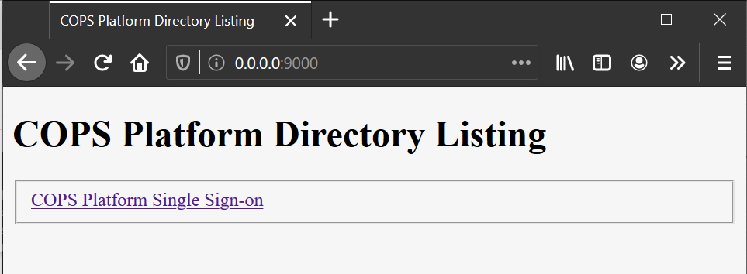

Figure 1: COPS Platform Directory Listing Page

### Logging in

The link from the directory listing page will take you to the COPS Platform Single Sign-on page. From there, you can enter your username and password. If generate_db.py has been run in the back-end, the only users will be student, instructor, and coordinator. As of the publication of this guide, the password field does not send anything to the back-end since there is no password authentication in the system. Just enter anything in the password field to log in.

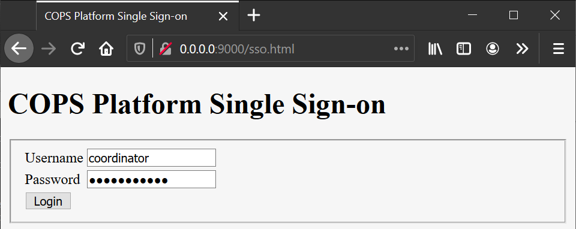

Figure 2: COPS Platform Single Sign-on page[1]

### Home

The home page as shown in Figure 3 shows all of the different actions you can take when logged in, each one representing one of the API calls in the system. For the purposes of showing off our SELinux security features, all API calls will be available for every user type to attempt. They will succeed or fail depending on the user’s role in the system.

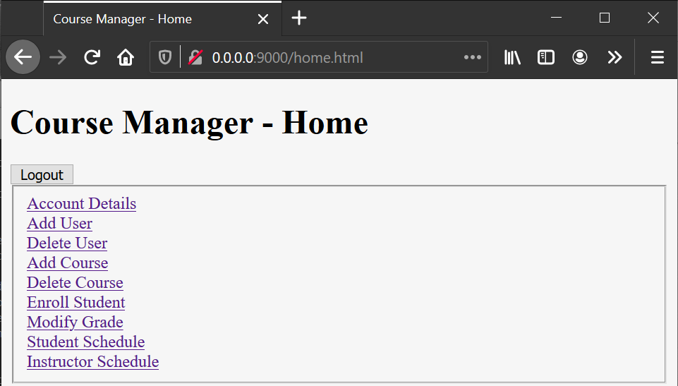

Figure 3: Homepage for all user types has a list of all possible API calls

### Account Details

The account details page will display your user ID, username, and name in a table as shown in Figure 4. If you are logged in as a student and have grades assigned to you, it will display your GPA as well. You can click the page header to return home. Any user type can view their details.

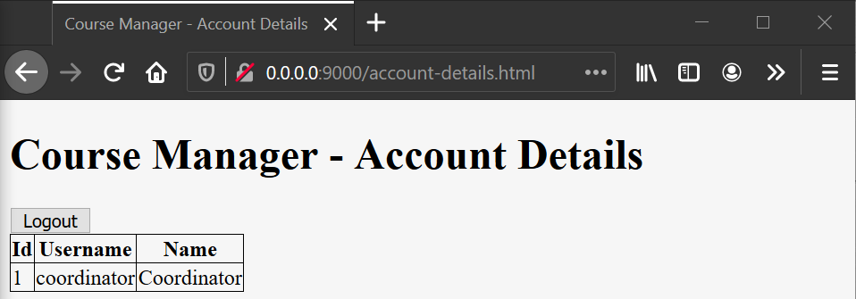

Figure 4: Account Details page for every user with id, username and name

### Add User

The add user page allows you to add a new user to the system, specifying their username, name, and role as shown in Figure 5. If SELinux is enforcing, only a coordinator should be able to do this.

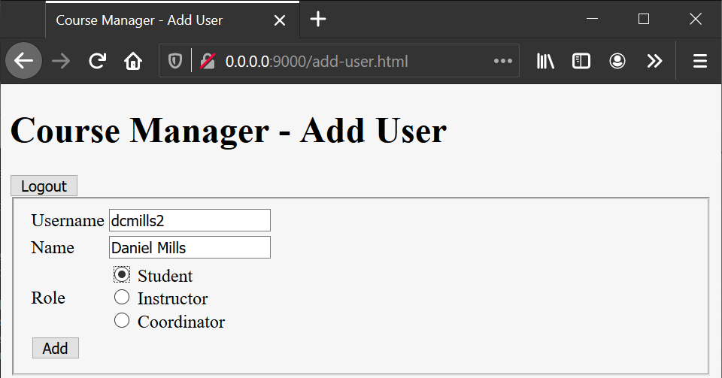

Figure 5: Add a new user with username, name and role

### Delete User

The delete user page allows you to delete a user from the system, specifying their username and role as in Figure 6. If SELinux is enforcing, only a coordinator should be able to do this. If the user is an instructor, any courses assigned to them will also be deleted.

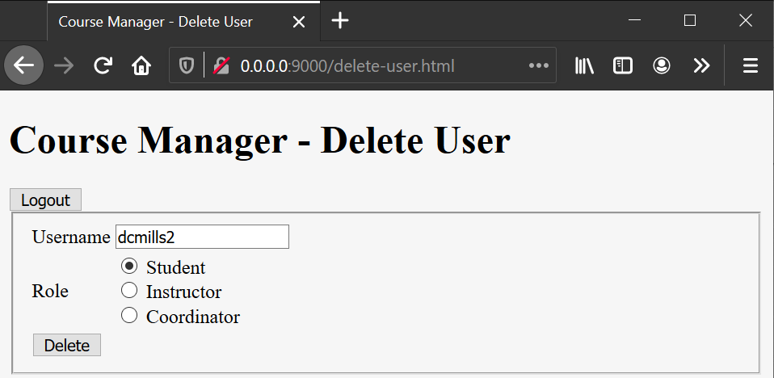

Figure 6: Delete an existing user with specified username and role

### Add Course

The add course page allows you to add a new course to the system, specifying its name, weekday, start time, end time, and instructor as seen in FIgure 7 below. If SELinux is enforcing, only a coordinator should be able to do this.

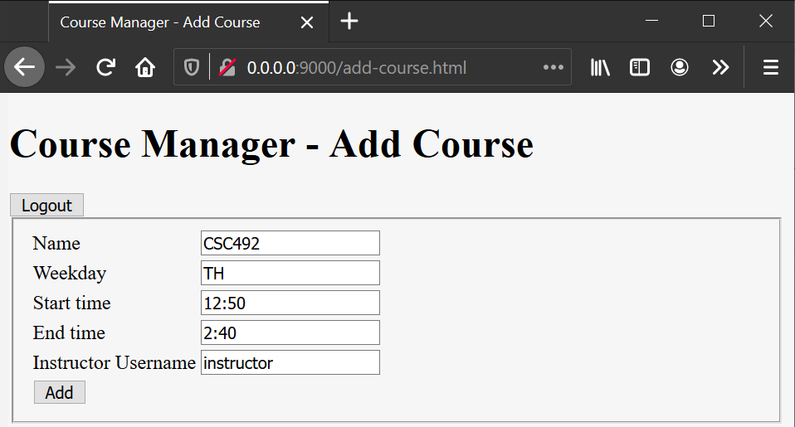

Figure 7: Add a new course by filling in required fields

### Delete Course

The delete course page allows you to delete a course from the system, by specifying its name (Figure 8). If SELinux is enforcing, only a coordinator should be able to do this. If any students or instructors are assigned to this course, it will be removed from their schedule.

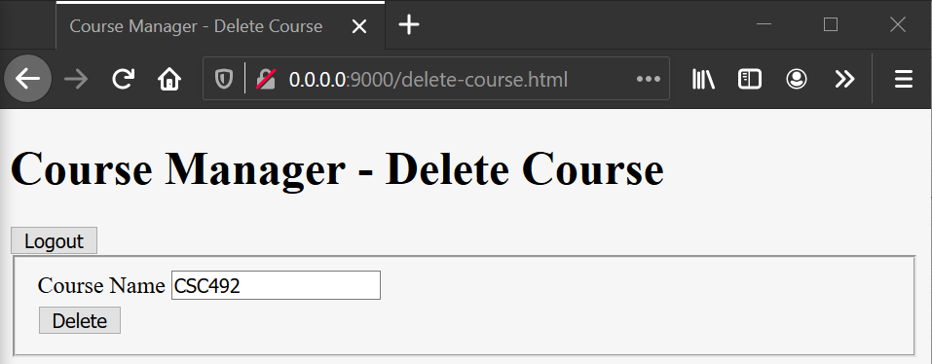

Figure 8: Delete an existing course by using course name

### Enroll Student

The enroll student page allows you to enroll a student in a course, specifying the username and course name (Figure 9). If SELinux is enforcing, only a coordinator should be able to do this.

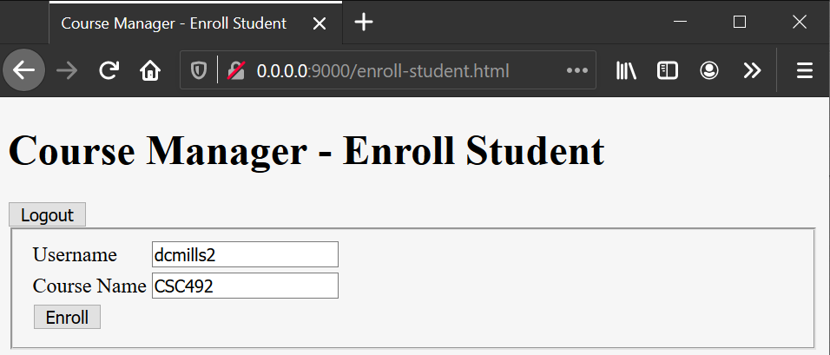

Figure 9: Enroll an existing student in an existing course

### Modify Grade

The modify grade page as shown in Figure 10 allows you to modify a student’s grade in a course, by specifying the username, course name, and grade (on the GPA scale). If SELinux is enforcing, only a coordinator or an instructor should be able to do this.

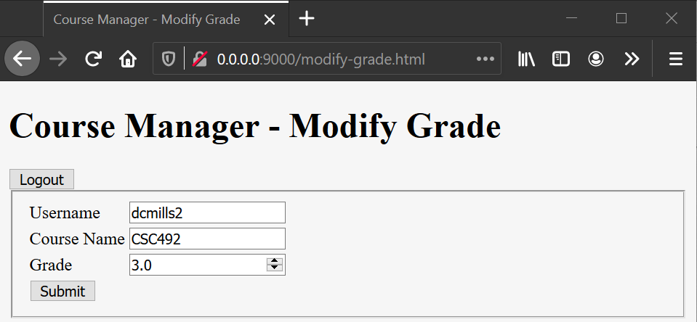

Figure 10: Modify grade for a student by entering a float gpa value

### Student Schedule

The student schedule page, if logged in as a student, will display the list of courses assigned to the student as in Figure 11. It will display the name, weekday, start time, end time, instructor, and grade of each course. You can click the page header to return home.

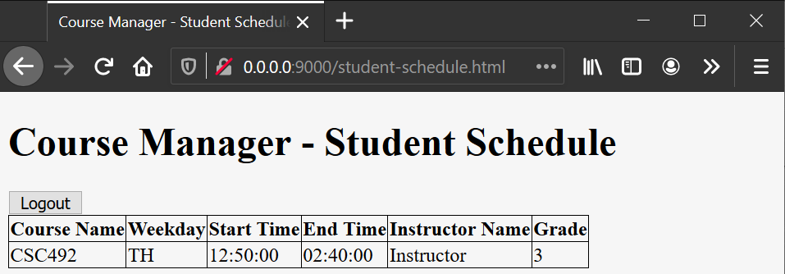

Figure 11: Student schedule page

### Instructor Schedule

The instructor schedule page (Figure 12), if logged in as an instructor, will display the list of courses assigned to the instructor. It will display the name, weekday, start and end time of each course, as well as a button to show the students enrolled in the course. You can click the page header to return home.

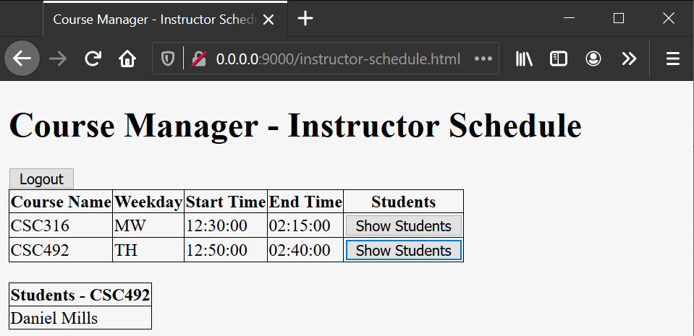

Figure 12: Instructor schedule page along with student roster

1. As of publication of this user guide, password field is non essential and non functional